***Java Programming***

***Section 3.3 practice***

**Genericstack:**

import java.util.ArrayList;

// GenericStackException class

class GenericStackException extends RuntimeException {

public GenericStackException(String message) {

super(message);

}

}

// GenericStack class

class GenericStack<T> {

private ArrayList<T> items;

private int top;

public GenericStack() {

items = new ArrayList<>();

top = 0;

}

private boolean isEmpty() {

return top == 0;

}

public void push(T item) {

items.add(item);

top++;

}

public T pop() {

if (isEmpty()) {

throw new GenericStackException("Underflow Error");

}

return items.remove(--top);

}

}

// StackDriver class

public class StackDriver {

public static void main(String[] args) {

GenericStack<Integer> stack = new GenericStack<>();

stack.push(1);

stack.push(2);

stack.push(3);

stack.push(4);

try {

for (int i = 0; i < 5; i++) {

System.out.println("Popped: " + stack.pop());

}

} catch (GenericStackException e) {

System.out.println(e.getMessage());

}

}

}

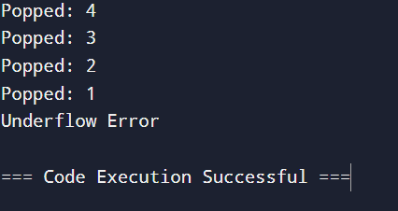

**Storing Courses and Their Codes Using a Map**

import java.util.HashMap;

import java.util.Map;

public class CourseCollection {

public static void main(String[] args) {

// 5a: Using a HashMap to store courses and their codes

Map<String, String> courses = new HashMap<>();

courses.put("CIT", "Computing and Information Technology");

courses.put("CHI", "Childcare and Early Education");

courses.put("MVS", "Motor Vehicle Systems");

courses.put("BTH", "Beauty Therapy");

courses.put("GDE", "Graphic Design");

// Printing out the list of courses

System.out.println("Course List:");

for (Map.Entry<String, String> course : courses.entrySet()) {

System.out.println(course.getKey() + ": " + course.getValue());

}

// 5b: Using the get method to retrieve the course name for a specific code

String courseCode = "CIT";

String courseName = courses.get(courseCode);

System.out.println("\nCourse name for code " + courseCode + ": " + courseName);

}

}

